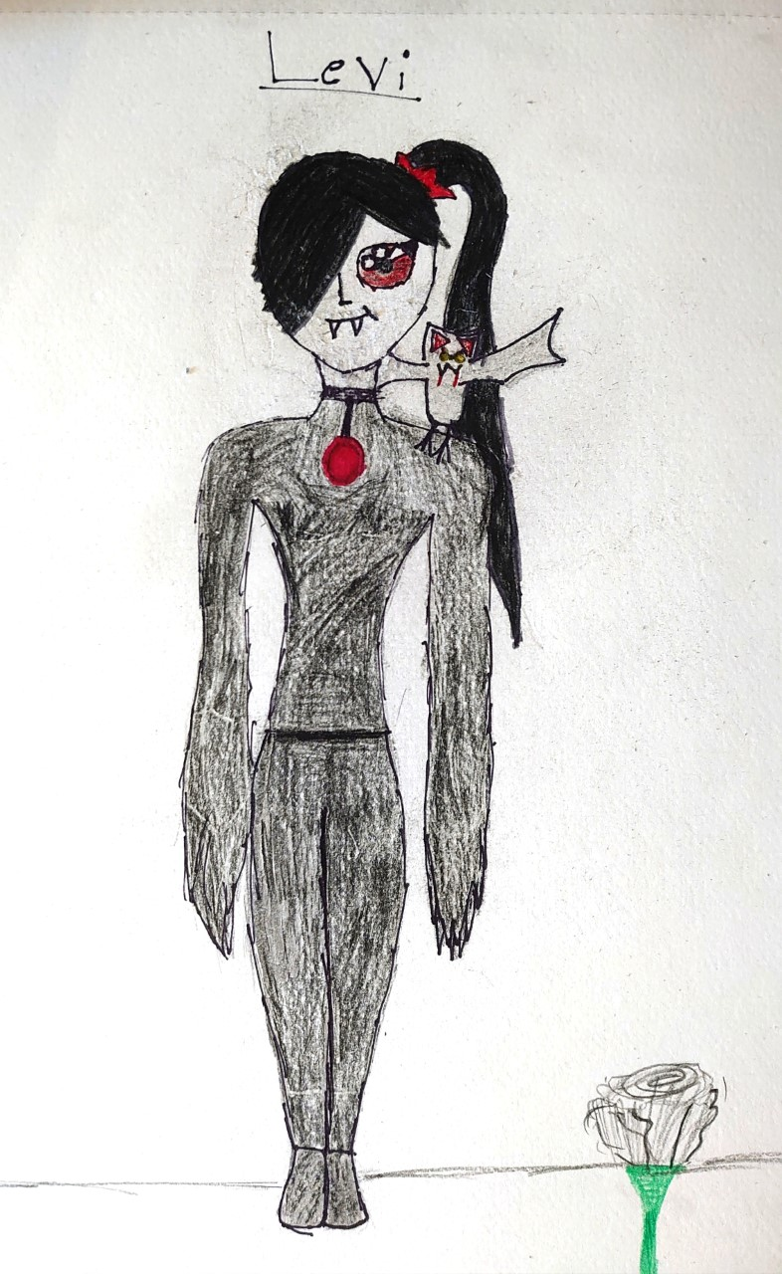
Levi
Appearance
She has jet black hair,
pale skin, she
wears black clothes,
she looks quite creepy, she wears
white gloves and
black shoes and she has fangs
the length of toothpicks and
she is female.
Personality
She is creepy and dark and loves to kill
She is strange and observant and
Likes to watch people, she is also very
mischievous and likes to do magic and
mess with your head.
Life
She Is A Vampire And Lives In A Forest Alone
She’s Very Poor And Has To Kill To Survive and
Her best friend is her pet bat named Bloody Rose.

